**ONLINE PROPEERTY MANAGEMENT**

**Abstract:**

The main objective of this project is to bring the real estate industry online and enabling real estate industry participants to benefit from the Internet. Site acts as an interface between Individuals, brokers and realtors. Here the user can advertise his property for buying or for selling.

Site provides online real estate and related services to customers to make eye catching and full profit decisions related to buying, selling, renting and leasing of properties, in India. We will provide a fresh new approach to our esteemed users to search for properties to buy or rent, and list their properties for selling or leasing. Property promises to be the most preferred way of finding your dream property and we are committed to help you make a wiser property decision, as a buyer or a seller.

**SYSTEM CONFIGURATION:**

**HARDWARE CONFIGURATION:**

**PROCESSOR - PENTIUM-III**

Speed - 1.1 GHz

Ram - 256 MB (min)

Hard Disk - 20 GB

**SOFTWARE CONFIGURATION:**

Operating System : Windows95/98/2000/XP

Application Server : Tomcat5.0/6.X

Front End : Java

Database : Mysql

Database Connectivity : JDBC.

**EXISTING SYSTEM**

If customer is interested in buying that flats, Developer sales the property/flat by completing all formalities, and makes entry into the Customer Details Register manually. All the permanent data of the order such as the name of the property/flat, Estate_ID, as well as name of buyer/customer, Member_ID and so on are maintained in a master file for future reference. The customer has the option of paying by cash or check or credit card. At the time customer pays the price he is issued a receipt acknowledging the same

**Disadvantages**

* All the above-mentioned tasks are taken care off manually.
* The details of all the Properties, customers, stocks and feedbacks are maintained in separate registers

**PROPOSED SYSTEM**

The user can have fast interaction with the system by inserting keywords at the respective places, by clicking on the buttons or links etc. Because not only the front end provides the faster interaction with the records but with back end also provides the proper interaction with the records and gives or prompts the information to the end user if he is making error during work.

**Advantages**

* Searching feature is quite faster than current system. Because it searches directly from system that is from the front end.
* The most important feature of this system is online exhibiting the properties, This saves time to visit at the actual place where the property is located

**Modules:**

The Project contains Five Main Modules are

**Admin Profile:**

Admin profile is profiled which is assigned to a superuser having full access to the system. Admin module contains Admin Id, name, address, contact no. Admin can view the property details make changes if required, delete the property details. Check the payment status, view, and manage the client details. Any issue in the client’s details or in property details just reports to the admin.

**Client Profile:**

The client profile is for those who want to buy, sell, or rent the property for their uses. Client profile contains Client id, name, address, contact details, etc. Clients can view the property. If it is available and the client is willing to buy or rent. They can pay online or offline.

**Property Details:**

Property details hold the data about the property in property location, total value, owner, etc. The property gives an idea about the property which helps the clients to choose the property.

**Search Property:**

There is a lot of property. Clients may be confused to search their desired property. Clients can search property using property types like residence, offices, faculty, and etc. Property can be searched by property status. Property can also be searched using property value and much more. If there is some legal problem with the property. Then it would be unavailable to rent or buy.

**Availability:**

Searched property can be viewed as available or not. The client can book the property only if it is available. Sold property can be hidden from the page. This would decrease the conflict between buyers and sellers.

**Booking:**

Once the property is searched and the client finds the desired property. This module helps the client to book the property. This module collects the information and checks the information from the backend. If data is verified then the client redirects to the payment page.

**DATA FLOW DIAGRAM**

**LEVEL 0:**

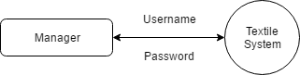

**LEVEL 1:**

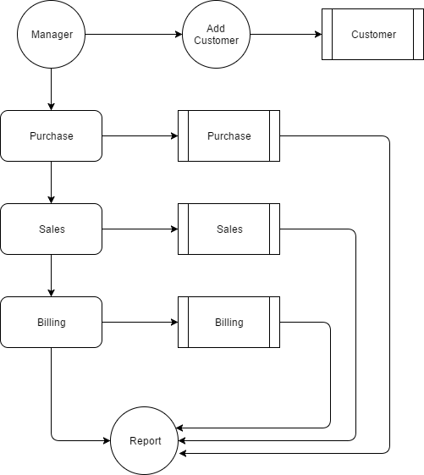

**TABLE DESIGN**

**TABLE NAME : CUSTOMER**

**PRIMARY_KEY : CID**

|  |  |  |  |
| --- | --- | --- | --- |
| **FIELD** | **DATA TYPE** | **SIZE** | **DESCRIPTION** |
| cid | Int |  | Customer id |
| Cname | Varchar | 30 | Customer name |
| Contact | Varchar | 10 | Contact no |
| Caddress | Text |  | Contact address |

**TABLE NAME : PURCHASE**

**PRIMARY_KEY : PID**

|  |  |  |  |
| --- | --- | --- | --- |
| **FIELD** | **DATA TYPE** | **SIZE** | **DESCRIPTION** |
| pid | Int | 10 | Purchase id |
| Pname | Varchar | 30 | Purchase name |
| Quantity | Int | 10 | Purchase Quantity |
| Price | Int | 10 | Purchase amount |
| Date | Date | 20 | Purchase date |
| Time | Time | 20 | Purchase time |

**TABLE NAME : SALES**

**PRIMARY_KEY : SID**

|  |  |  |  |
| --- | --- | --- | --- |
| **FIELD** | **DATA TYPE** | **SIZE** | **DESCRIPTION** |
| sid | Int | 10 | Sales id |
| Sname | Varchar | 30 | Sales name |
| Quantity | Int | 10 | Sales Quantity |
| Price | Int | 10 | Sales amount |
| Date | Date | 20 | Sales date |
| Time | Time | 20 | Sales time |

**TABLE NAME : BILLING**

**PRIMARY_KEY : BID**

**FOREIGN KEY : PID,CID**

|  |  |  |  |
| --- | --- | --- | --- |
| **FIELD** | **DATA TYPE** | **SIZE** | **DESCRIPTION** |
| Bid | Int | 10 | Billing id |
| Pid | Int | 10 | Purchase id |
| cid | Int | 10 | Customer id |
| Quantity | Int | 10 | Billing Quantity |
| Price | Int | 10 | Price of product |
| Time | Time | 20 | Sales time |
| Date | Date | 20 | Sales date |